**Equity Research**

Season of Code

Anubhav Yadav

Content

1. **Introduction to Stock Market**

What is investing? Why invest? Where to invest?  . . . . . . . . . . . . . . . . . . . . . . (2)

Stock Market and its participants . . . . . . . . . . . . . . . . . . . . . . . . . . . . . . . . . . . . (3)

Fundamental Analysis . . . . . . . . . . . . . . . . . . . . . . . . . . . . . . . . . . . . . . . . . . . . . (7)

Financial Ratios. . . . . . . . . . . . . . . . . . . . . . . . . . . . . . . . . . . . . . . . . . . . . . . . . . . (11)

Technical Analysis. . . . . . . . . . . . . . . . . . . . . . . . . . . . . . . . . . . . . . . . . . . . . . . . . (14)

1. **Equity Research**

Understanding the business . . . .. . . . . . . .. . . . .. . . . . . . .. . . . . .. . . . .. . . .. .

1. **Introduction to Stock Market**

* **What is investing? Why invest? Where to invest?**

It is generally considered ideal to invest your savings to have a secure future. Most compiling reasons to invest your savings are:  
**1. Fight Inflation** – By investing, one can deal better with the inevitable reality of life – the growing cost of living – generally referred to as Inflation.

**2. Create Wealth** – By investing, one can build a bigger corpus by the end of the target period. In the above example, the period was up to retirement, but it can be anything – children’s education, marriage, house purchase, retirement holidays, etc

**3. Better life** – To meet life’s financial aspirations.

Having figured out the reasons to invest, the next obvious question is – where would one invest, and what return can one expect with investing? When investing, one has to choose an **asset class** that suits the individual’s risk and returns profile.

The following are some of the popular asset classes.

1. **Fixed Income Instruments :**

Fixed-income instruments are investment avenues where your principal amount (the money you invest) is perceived to be safe.

A few examples for fixed-income instruments are –

1. Bank’s Fixed deposits ( ~ 5-6% returns)
2. Bonds issued by the Government of India (also called G Sec bonds and T Bills)(~5% returns)
3. Bonds issued by Government related agencies such as GAIL, HUDCO, NHAI, etc
4. Bonds issued by corporate’s (Tata, Bajaj, Reliance, Adani)(~10% returns)
5. **Equity :**

Investment in Equities involves buying shares of publicly listed companies. Indian Equities have generated upwards of 12% CAGR (compound annual growth rate) over the past 10 to 15 years.

1. **Real Estate:**

Real Estate Investment involves transacting (buying and selling) commercial and non-commercial land.  There are two income sources from real estate investments: Rental income and Capital appreciation of the investment amount. The transaction procedure can be quite complex involving legal verification of documents. The cash outlay in real estate investment is usually quite large.

1. **Commodities:**

Gold and silver are considered one of the most popular investment options.  Gold and silver, over the long term, have appreciated. Investments in these metals have yielded a CAGR return of approximately 5-8% over the last 20 years.

**Our focus will be understanding the Equity investment in detail:**

* **Stock Market and its participants**

The stock market is where all the participants who wish to transact in shares go. Transact means to buy or sell shares in the context of stock markets. The primary purpose of the stock market is to help you facilitate your transactions.

The stock market also comprises a set of participants that contribute to its smooth functioning. These participants are an integral link between buyers and sellers of various securities in the securities market.

The main participants include:  
**1. Regulator**

In India, the stock market regulator is called **The Securities and Exchange Board of India,** often referred to as SEBI. SEBI aims to promote the development of stock exchanges, protect the interest of retail investors, and regulate market participants’ and financial intermediaries’ activities. Major role of SEBI includes :

* Protects investor’s interests in securities by conducting awareness programs
* Regulates stock market activities
* Prevents fraud or malpractices
* Helps develop the Indian Stock Market
* Grants investment advisory licenses

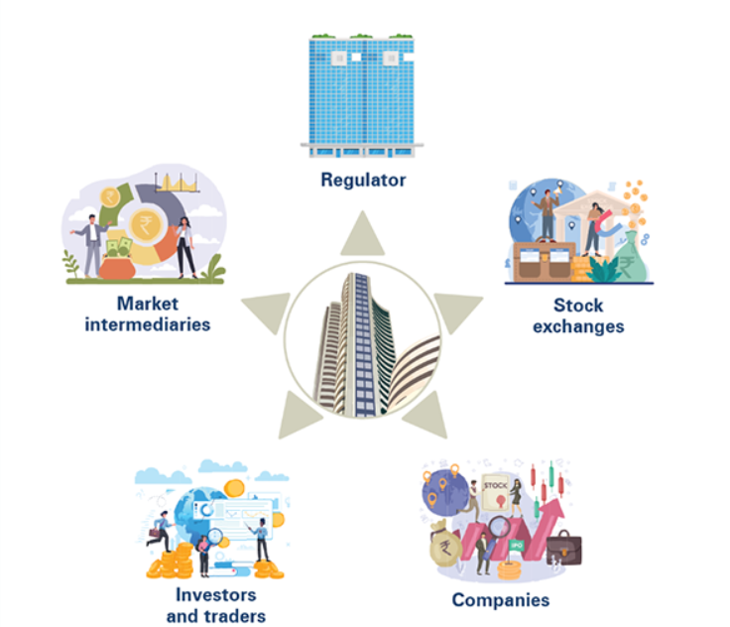

**2. Stock Exchanges**

The stock exchange also known as a securities exchange is a trading platform. It facilitates the registered stockbrokers and investors, often through a stock trading app, to transact in securities electronically. India has two premier stock exchanges include National Stock Exchange (NSE) and the and BSE Limited (BSE).

**3. Companies**

Every share that you see available to be purchased or sold in the stock market today are those issued by publicly traded companies. When a company makes an Initial Public Offer (IPO), it becomes publicly traded, which means it introduces itself in the stock exchange.

**4. Traders**

When you invest in a publicly listed company in the stock exchange, you are regarded as an investor.

**5. Market intermediaries**

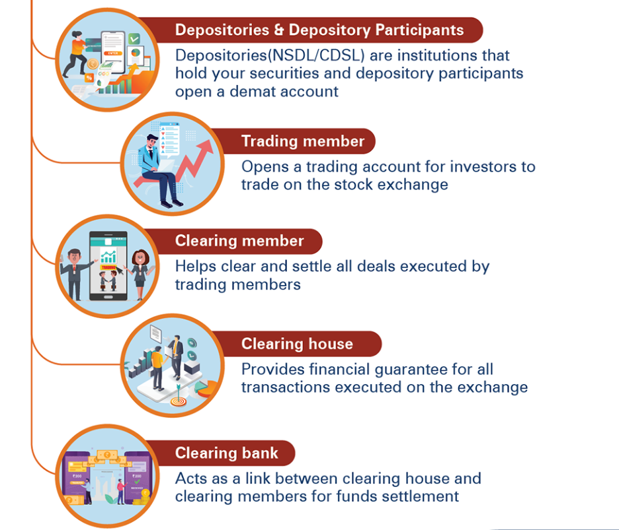

Each market participant has a unique style of participating in the market.

They can be categorised as an investor or a trader.

A trader is a person who spots an opportunity and initiates the trade with an expectation of profitably exiting the trade at the earliest given opportunity. There are different types of traders :

* 1. **Day Trader** – A day trader initiates and closes the position during the day. He does not carry forward trading positions overnight.
  2. **Scalper** – A type of day trader. A scalper usually trades very large shares and holds the stock for less time to make a small but quick profit.
  3. **Swing Trader** – A swing trader holds on to the trade for a slightly longer; the duration can run anywhere between a few days to weeks

An investor is a person who buys a stock expecting a significant appreciation in the stock. The investor is willing to wait for the investment to evolve. There are two popular types of investors.

1. **Growth Investors** – The objective here is to identify companies expected to grow significantly because of emerging industry and macro trends.
2. **Value Investors** – The objective here is to identify good companies irrespective of whether they are in the growth or mature phase but beaten down significantly due to the short-term market sentiment, thereby making a great value buy.

How to calculate returns?

***Compounded Annual Growth Rate (CAGR)****–* An absolute return can be misleading if you want to compare two investments. CAGR factors in the time component, which we had ignored when we computed the absolute return.

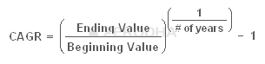

* **Fundamental Analysis**

Fundamental Analysis (FA) is a holistic approach to study a business. When an investor wishes to invest in a business for the long term (say 3 – 5 years), it becomes essential to understand the business from various perspectives. It is critical for an investor to separate the daily short term noise in the stock prices and concentrate on the underlying business performance. Over the long term, a fundamentally strong company’s stock prices tend to appreciate, thereby creating wealth for its investors.

Even trader looking to have short term investment in a company should have the knowledge of Fundamental analysis.

The process of evaluating a fundamentally strong company includes a study of ‘Qualitative aspect’ and the ‘Quantitative aspects’ of the company.

We obtain information about these aspects of a company by reading the ‘Annual Report’ of the company.

**Reading an Annual Report:**

The annual report has many sections that contain useful information about the company. One has to be careful while going through the annual report as there is a fragile line between the company’s facts and the marketing content that the company wants you to read.

Note, no two annual reports are the same; they are all made to suit the company’s requirement keeping in perspective the industry they operate in. However, some of the sections in the annual report are common across annual reports.

The sections like the ‘**Management Statement**’ and ‘**Management Discussion & Analysis**’, are quite important. These sections give you a sense of what the company’s management has to say about their business and the industry in general. As an investor or a potential investor in the company, every word mentioned in these sections is important.

Next, section like the ‘**Management Discussion & Analysis**’ or ‘MD&A’.

It is perhaps one of the most important sections in the whole of AR. The most standard way for any company to start this section is by talking about the macro trends in the economy. They discuss the overall economic activity of the country and the business sentiment across the corporate world. If the company has high exposure to exports, they even talk about global economic and business sentiment.

Finally, the last section of the AR contains **the financial statements** of the company. Lets look them in a bit more detail.

**Profit and Loss statement:**

The P&L statement reports information on:

1. The revenue of the company for the given period (yearly or quarterly)
2. The expenses incurred to generate the revenues
3. Tax and depreciation
4. The earnings per share number

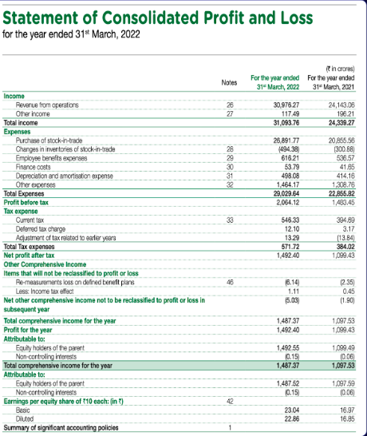

**Balance Sheet:**

While P&L statement tell mostly about revenues and expenses for a particular period of time, on the other hand Balance sheet gives us information about the assets, liabilities, and shareholder’s equity on a particular date since the time it was incorporated.

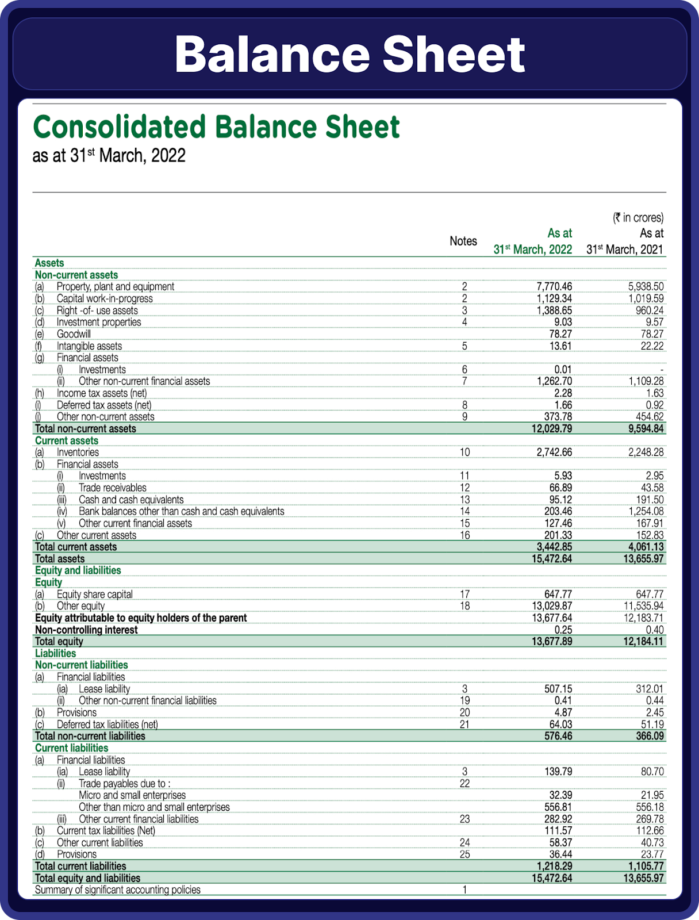

the Assets of the company should be equal to the Liabilities of the company. This is because everything that a company owns (Assets) has to be purchased either from either the owner’s capital or liabilities.

Owners Capital is the difference between the Assets and Liabilities. It is also called the ‘Shareholders Equity’ or the ‘Net worth’. Representing this in the form of an equation:

**Shareholders equity = Assets – Liabilities**

**Relation between balance sheet and P&L statement :**

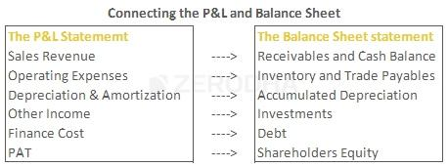

**Cash Flow Statement:**

Typically when companies present their cash flow statement, they split the statement into three segments to explicitly show how much cash the company has generated across the three business activities.

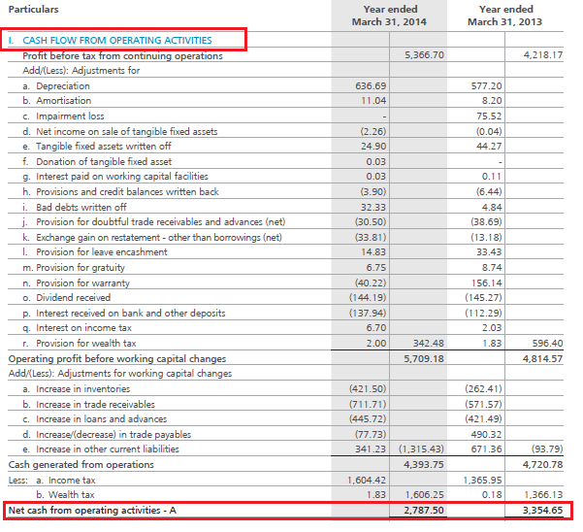

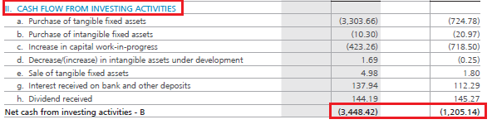

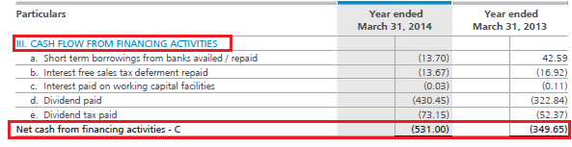

The Statement of Cash flow is a useful addition to a company’s financial statements because it indicates the company’s performance.

After Reading these financial statements from Annual Report , Next we have to analyse them, and for that we have to have an understanding of the Financial Ratios.

* **Financial Ratios**

Financial ratios are grouped into the following categories:

1. **Leverage ratios**

[Leverage ratios](https://corporatefinanceinstitute.com/resources/accounting/leverage-ratios/) measure the amount of capital that comes from debt. In other words, leverage financial ratios are used to evaluate a company’s debt levels. Common leverage ratios include the following:

The [debt ratio](https://corporatefinanceinstitute.com/resources/commercial-lending/debt-to-asset-ratio/) measures the relative amount of a company’s assets that are provided from debt:

**Debt ratio = Total liabilities / Total assets**

The [debt to equity ratio](https://corporatefinanceinstitute.com/resources/commercial-lending/debt-to-equity-ratio-formula) calculates the weight of total debt and financial liabilities against shareholders’ equity:

**Debt to equity ratio = Total liabilities / Shareholder’s equity**

The [interest coverage ratio](https://corporatefinanceinstitute.com/resources/commercial-lending/interest-coverage-ratio/) shows how easily a company can pay its interest expenses:

**Interest coverage ratio = Operating income / Interest expenses**

The debt service coverage ratio reveals how easily a company can pay its debt obligations:

**Debt service coverage ratio = Operating income / Total debt service**

1. **Liquidity ratios**

Liquidity ratios are financial ratios that measure a company’s ability to repay both short- and long-term obligations. Common liquidity ratios include the following:

The [current ratio](https://corporatefinanceinstitute.com/resources/accounting/current-ratio-formula/) measures a company’s ability to pay off short-term liabilities with current assets:

**Current ratio = Current assets / Current liabilities**

The [acid-test ratio](https://corporatefinanceinstitute.com/resources/accounting/acid-test-ratio/) measures a company’s ability to pay off short-term liabilities with quick assets:

**Acid-test ratio = Current assets – Inventories / Current liabilities**

The [cash ratio](https://corporatefinanceinstitute.com/resources/accounting/cash-ratio-formula/) measures a company’s ability to pay off short-term liabilities with cash and cash equivalents:

**Cash ratio = Cash and Cash equivalents / Current Liabilities**

The [operating cash flow ratio](https://corporatefinanceinstitute.com/resources/accounting/operating-cash-flow-ratio/) is a measure of the number of times a company can pay off current liabilities with the cash generated in a given period:

**Operating cash flow ratio = Operating cash flow / Current liabilities**

1. **Efficiency ratios**

Efficiency ratios, also known as activity financial ratios, are used to measure how well a company is utilizing its assets and resources. Common efficiency ratios include:

The [asset turnover ratio](https://corporatefinanceinstitute.com/resources/accounting/asset-turnover-ratio/) measures a company’s ability to generate sales from assets:

**Asset turnover ratio = Net sales / Average total assets**

The [inventory turnover ratio](https://corporatefinanceinstitute.com/resources/accounting/inventory-turnover/) measures how many times a company’s inventory is sold and replaced over a given period:

**Inventory turnover ratio = Cost of goods sold / Average inventory**

The accounts receivable turnover ratio measures how many times a company can turn receivables into cash over a given period:

**Receivables turnover ratio = Net credit sales / Average accounts receivable**

The [days sales in inventory ratio](https://corporatefinanceinstitute.com/resources/financial-modeling/days-sales-in-inventory/) measures the average number of days that a company holds on to inventory before selling it to customers:

**Days sales in inventory ratio = 365 days / Inventory turnover ratio**

1. **Profitability ratios**

[Profitability ratios](https://corporatefinanceinstitute.com/resources/accounting/profitability-ratios/) measure a company’s ability to generate income relative to revenue, balance sheet assets, operating costs, and equity. Common profitability financial ratios include the following:

The [gross margin ratio](https://corporatefinanceinstitute.com/resources/accounting/gross-margin-ratio/) compares the gross profit of a company to its net sales to show how much profit a company makes after paying its cost of goods sold:

**Gross margin ratio = Gross profit / Net sales**

The [operating margin ratio](https://corporatefinanceinstitute.com/resources/accounting/operating-profit-margin/), sometimes known as the return on sales ratio, compares the operating income of a company to its net sales to determine operating efficiency:

**Operating margin ratio = Operating income / Net sales**

The [return on assets ratio](https://corporatefinanceinstitute.com/resources/accounting/return-on-assets-roa-formula/) measures how efficiently a company is using its assets to generate profit:

**Return on assets ratio = Net income / Total assets**

1. **Market value ratios**

Market value ratios are used to evaluate the share price of a company’s stock. Common market value ratios include the following:

The book value per share ratio calculates the per-share value of a company based on the equity available to shareholders:

**Book value per share ratio = (Shareholder’s equity – Preferred equity) / Total common shares outstanding**

The dividend yield ratio measures the amount of dividends attributed to shareholders relative to the market value per share:

**Dividend yield ratio = Dividend per share / Share price**

The earnings per share ratio measures the amount of net income earned for each share outstanding:

**Earnings per share ratio = Net earnings / Total shares outstanding**

The [price-earnings ratio](https://corporatefinanceinstitute.com/resources/valuation/price-earnings-ratio/) compares a company’s share price to its earnings per share:

**Price-earnings ratio = Share price / Earnings per share**

* **Technical Analysis**

One of the greatest advantages of technical analysis is that you can apply TA on any asset class as long as the asset type has historical time series data. Time series data in technical analysis is the price information, namely – open high, low, close, volume, etc.

A Candlestick chart is the most popular form of price chart used by traders. In a candlestick chart, the price graph is represented in the form of a series of candles, hence it is called a candlestick chart.

The chart is made up of red and green candles where each candle gives information about opening, closing and range of trading prices within a particular time frame.

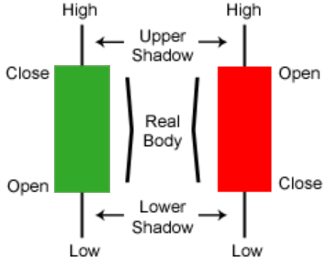

Another part of technical analysis is the use of Technical Indicators.

Indicators belong to one of the following types: Trend, momentum, volatility or volume indicators.

Trend indicators are designed to show traders and investors the trend or direction of the asset they are trading. Moving averages, MACD, average directional index, parabolic SAR, linear regression, forecast oscillator are some example of trend indicators.

Momentum traders focus on stocks or assets that are moving significantly in one direction on high volume. For that, they use momentum indicators such as the RSI, Stochastics, CCI, Commodity channel index, Chande’s momentum oscillator and Williams %R.

The volatility is the relative rate at which the price of a security moves (up and down). Some of the volatility indicators available for traders are Bollinger bands, Envelopes, Average true range, Volatility channels indicator, Volatility chaikin and Projection oscillator.

Many indicators are also based on volume. Examples are Ease Of movement, Chaikin money flow, On balance volume, Demand index and Force index.

These indicators will be discussed in greater details in the later sections.

1. Equity Research (Manually)

 We will structure the equity research process in 3 stages-

1. Understanding the Business
2. Application of the checklist
3. Intrinsic Value estimation (Valuation) to understand the fair price of the stock

**Understanding the Business**

As a first step towards understanding the business, we need to make a list of questions we need to find answers to. Do note, the answers to all these questions can be found out by reading through the company’s annual report and website.

Stage 1 of the equity research process helps us understand how, what, who, and why. It helps us develop a holistic view of the company

This includes things mentioned in the reading Annual report section above.

Also we look at the macroeconomics and different social, political factors that can affect the company.